Ideation Phase

Brainstorm & Idea Prioritization Template

|  |  |
| --- | --- |
| Date | 16 June 2025 |
| Team ID | LTVIP2025TMID55860 |
| Project Name | Shopsmart: Your Digital Grocery |
| Maximum Marks | 4 Marks |

# Brainstorm & Idea Prioritization Template:

Brainstorming provides a free and open environment that encourages the ShopSmart team to creatively explore ideas that enhance the online grocery shopping experience.

Prioritizing volume over value, innovative and customer-centric ideas are welcomed and built upon, empowering every team member to contribute freely and shape the future of ShopSmart.

Use this updated template in your brainstorming sessions to collaborate remotely or in person and unlock fresh features, smarter solutions, and a more seamless digital grocery platform.

Reference: <https://www.mural.co/templates/brainstorm-and-idea-prioritization>

# Step-1: Team Gathering, Collaboration and Select the Problem Statement

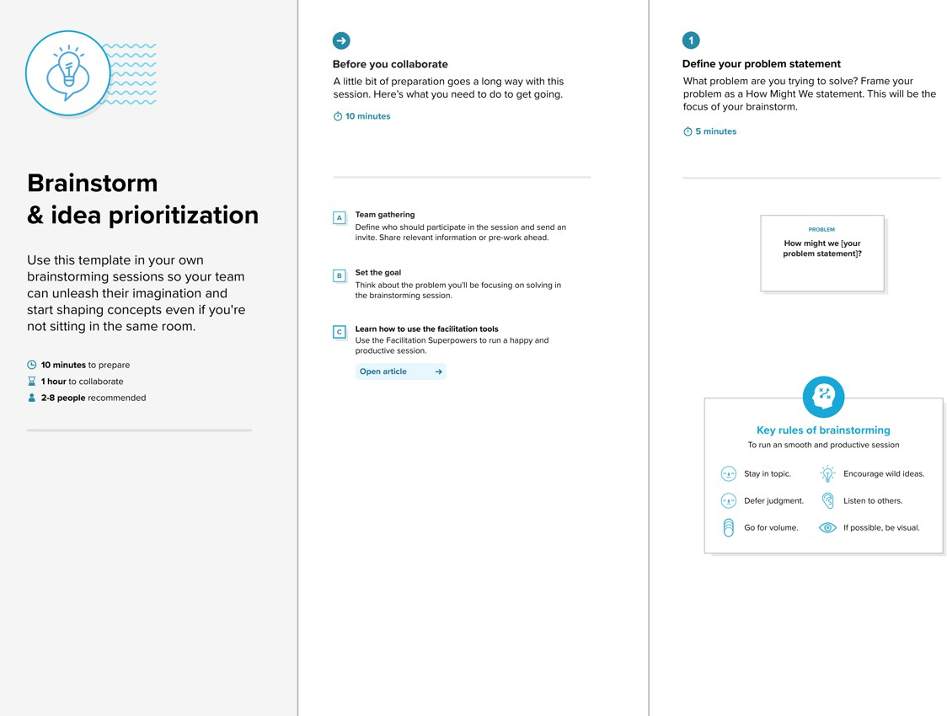

**Step-2: Brainstorm, Idea Listing and Grouping**

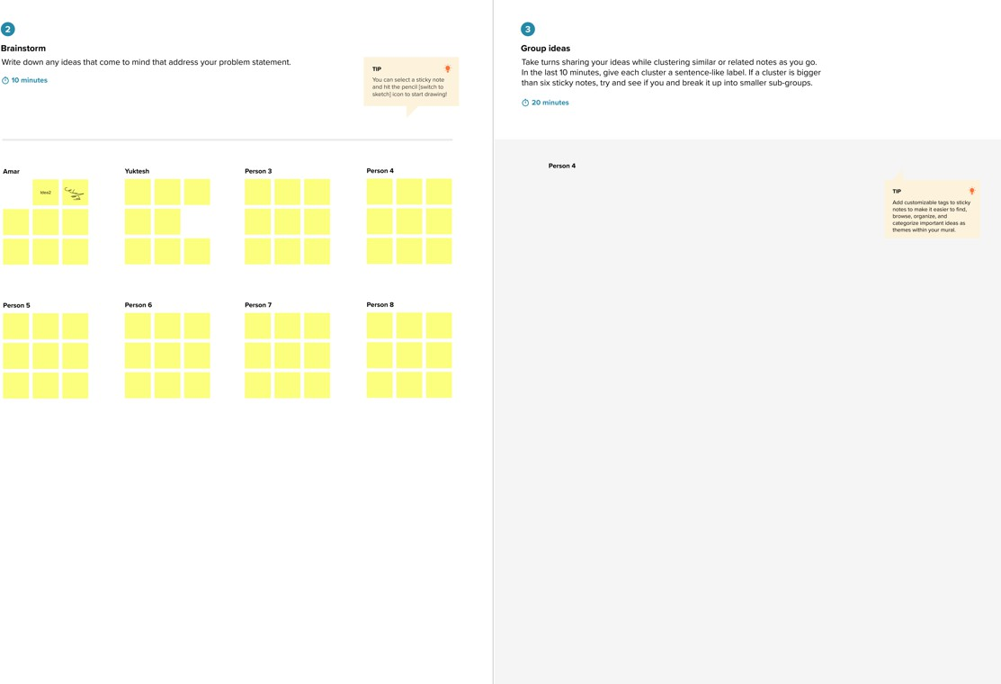

**Step-3: Idea Prioritization**

